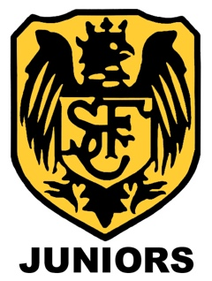

Stotfold Junior Football Club
Refund Policy

Stotfold Junior Football Club have set the following guidelines on refunds with regards to registration fees.

To request a refund, a written email should be sent to the Club Chairman at chairman@stotfoldjuniorfc.co.uk with a detailed explanation for the request. After the request has been received the Clubs Executive Committee will review and decide of how to move forward with the refund and how much of the cost will be refunded.

Refunds will be assessed based on the following:

- Leaving the Club before Teams have been registered to the County or League
- Leaving the Club after completing the new seasons registration
- Leaving the Club during the playing season
- Leaving the Club due to moving out of the catchment area
- Having sustained an injury preventing the ability to train or play matches
- The Team folding without previsions made to allow training and matches to continue

Unfortunately, refunds will not be made due to the following:

- Positional play within the Team
- Time allocated during match play
- Change of training/match time or day
- Missed training/matches due to non-attendance
- Leaving the Club to follow other opportunities

The amount of money that is refunded is contingent on how much of the season has passed as well as the reason for the refund. 50% of the registration fee is paid upfront to cover County Fees, League Fees, Pitch Fees, Administration etc.

A guide to refunds is as follows:

- Refund of 90% within the first month of the season (September)
- Refund reducing to 50% to December
- Refund reducing to 25% to March

Refunds that are awarded will be returned by Bank Transfer to the bank account used to pay the original registration fee.

Stotfold Junior Football Club reserves the right to waive this Refund Policy at its sole discretion at any time. Such waiver shall generally be in response to extenuating or highly unusual circumstances, and in no event shall the Executive Committee be obligated to waive this Refund Policy.

Stotfold Junior Football Club Executive Committee

